

|  |
| --- |
| Employee & User management Features List  Super petro chemical limited |
| REFERENCE: GW/ERP/Features List |
|  |
| **Genweb2 Ltd.** |
| **23-Nov-21** |

Contents

A. Document Information 2

B. Document History 3

A. Introduction: 3

1. Employee 4

1.1 Create Employee 4

1.2 Approvers chain 5

2. Contracts 6

2.1 Create contracts 6

3. Departments 7

3.1 Create departments 7

4. User 8

4.1 Create user 8

4.2 Assign user role 9

# Document Information

|  |  |
| --- | --- |
| Document Name | Employee & User Management Features List |
| Document Author | Rashedul Alam |
| Document review | Mahfuzur Rahman |
| Document Version | 1.1 |
| Release Date | 23th Nov, 2021 |

# Document History

|  |  |  |  |  |  |
| --- | --- | --- | --- | --- | --- |
| A=Added, M=Modified, D=Delete | | | | | |
| **Version No** | **Date** | **Section No** | **A/M/D** | **Description of Change** | **Author** |
| 1.0 | 23-Nov-2021 |  | A | Initial | Rashedul Alam |
| 1.1 | 30-Nov-2021 |  | A/D | IOU remove, Approval chain add, List view placement modify. | Rashedul Alam |

# Introduction:

This Document is to clearly identify the customer requirements and provide a detailed document. This Features list will contain Employee & User management related all information. Customer will read this document and get a clear view the Employee & User management module. It will also help the review team to validate whether the customer requirements have been fulfilled or not.

# 1. Employee

HR manager/user will do new employee Profile creation.HR user also will create user contract, will define operating unit. Software user role will define also HR user.

## 1.1 Create Employee

Sometimes New employees are come in company then need to create employee profile here HR manager can create Employee profile & enter all employee information.

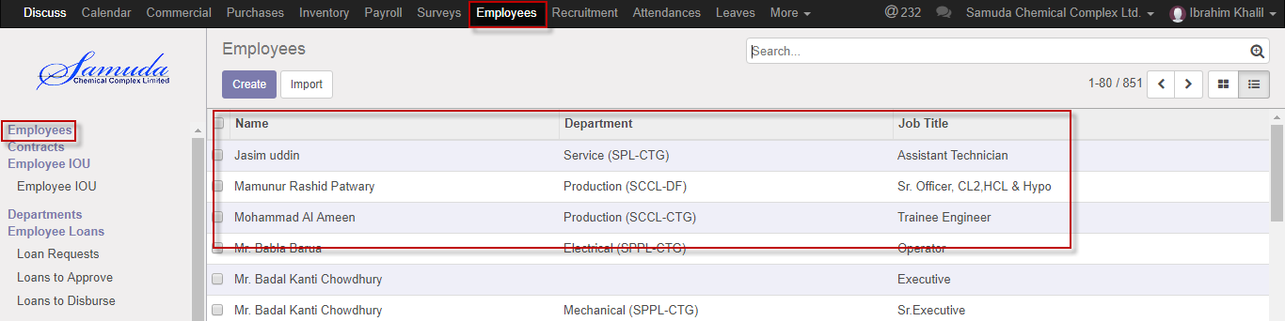

Figure: Employee List view

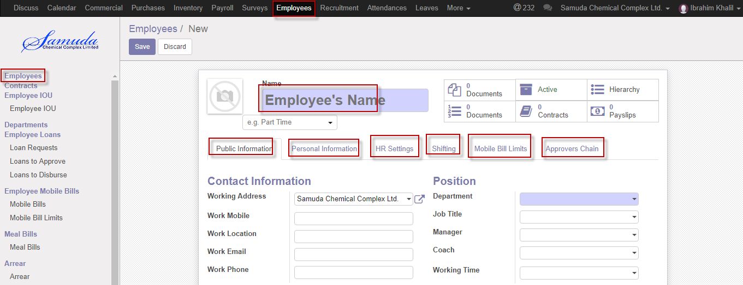

Figure: Create employee

## 1.2 Set custom chain level

Employee approver chain is exist to HR perspective.

It has also validation level. Validation level is customized, you are able to give validation level as per your requirement. If you select two then will show two level validation.

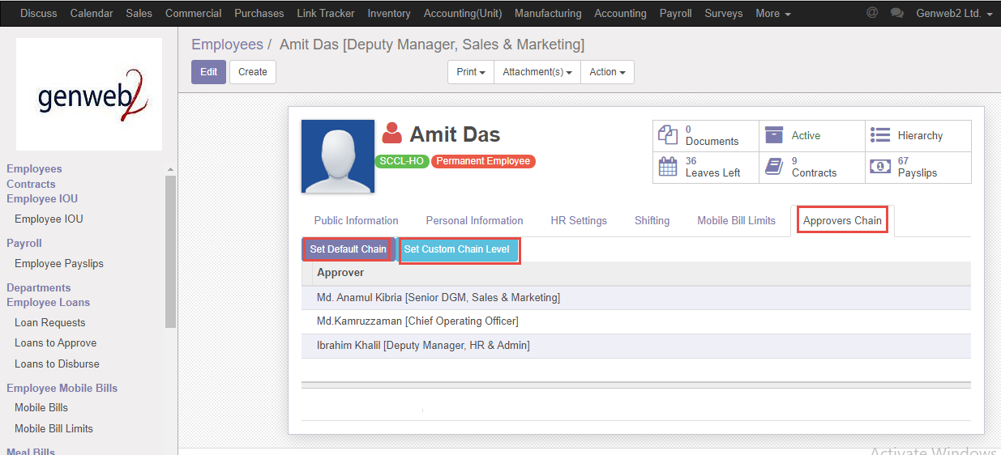

Figure: Default approver chain

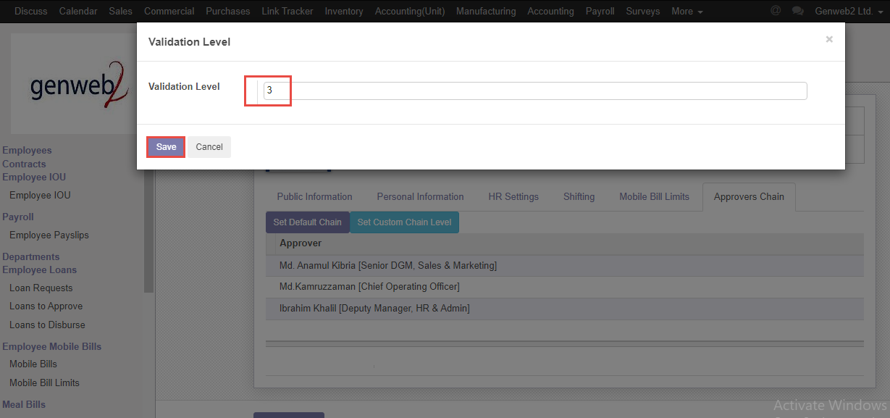

Figure: Validation level

# 2. Contracts

HR manager will create contract information after joining new employee.

## 2.1 Create contracts

New contracts creation require after join new employee.HR manger can do the information setup. Employee wage, Which Department under all info are given here.

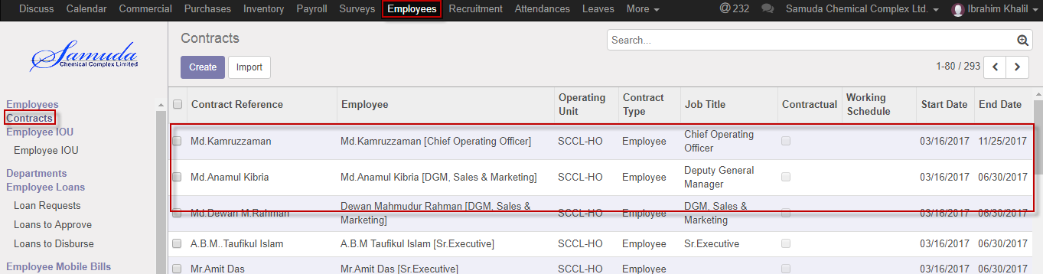

Figure: Contracts List view

# 3. Departments

HR manager will create departments and departments need for employee department setting which employee under which departments.

## 3.1 Create departments

HR user will create departments**.**

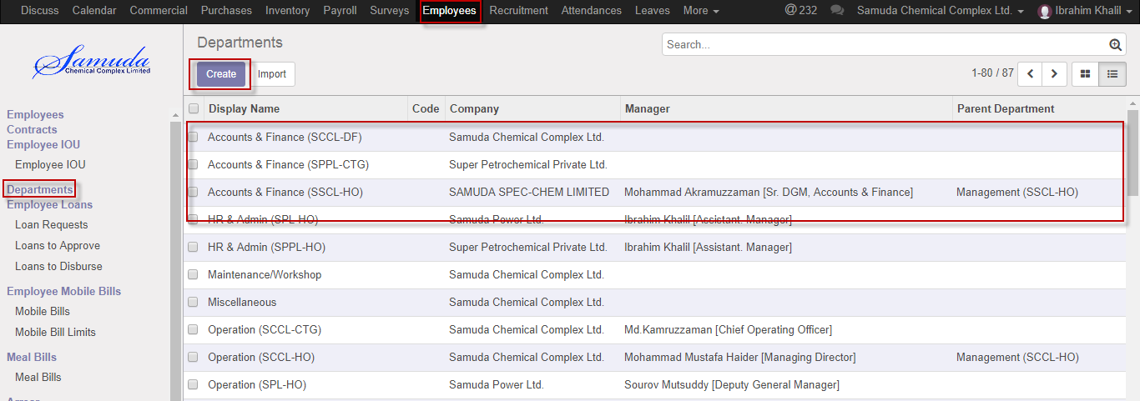

Figure: Departments List view

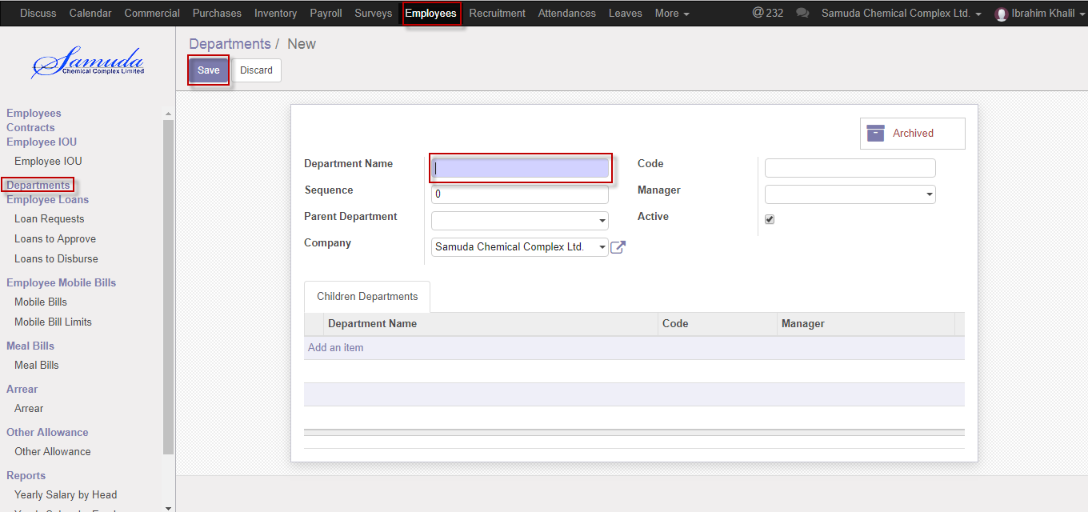

Figure: Create departments

# 4. User

HR manager will create departments and departments need for employee department setting which employee under which departments.

## 4.1 Create user

HR user will create departments**.**

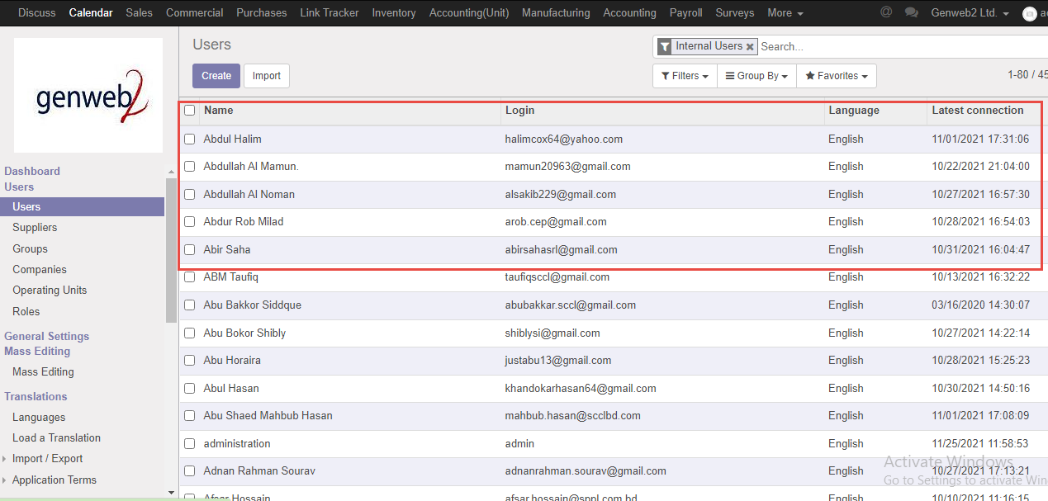

Figure: User List view

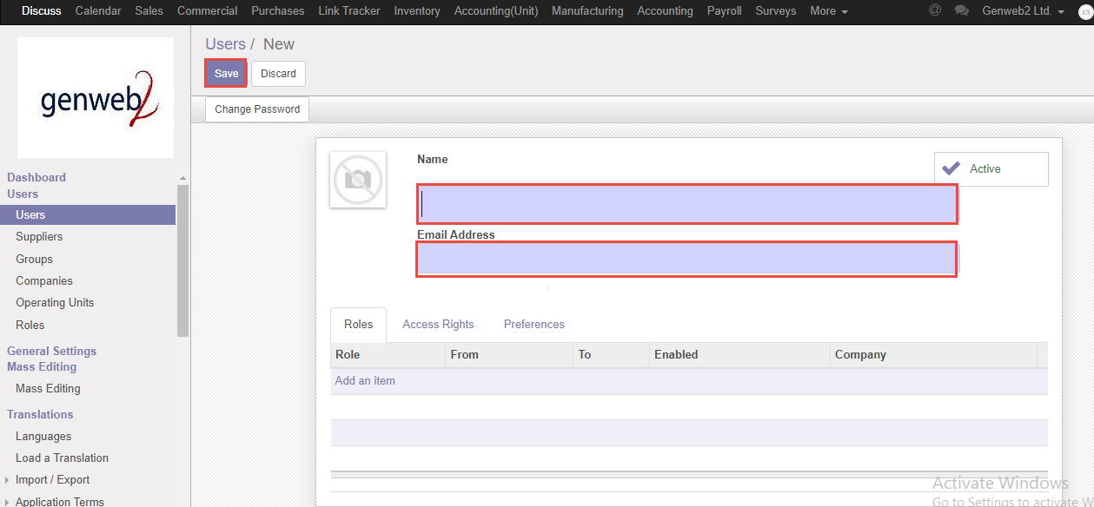

Figure: Create Users

## 4.2 Assign user role

HR user also will define individual user role.

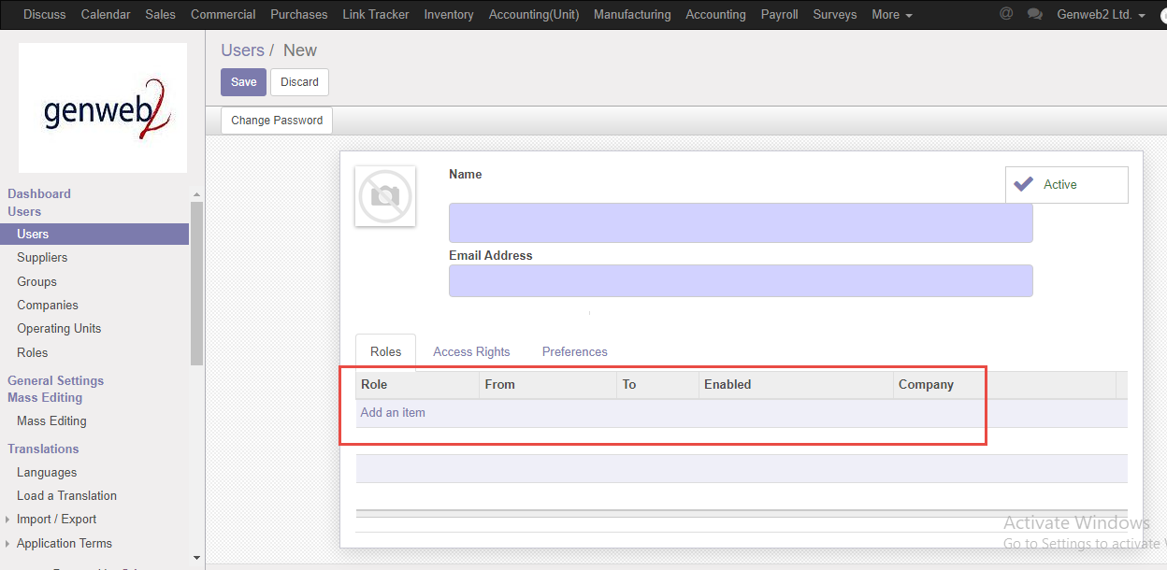

Figure: Assign user role